Responsive Design Exercises

Draw your Website Landing Page

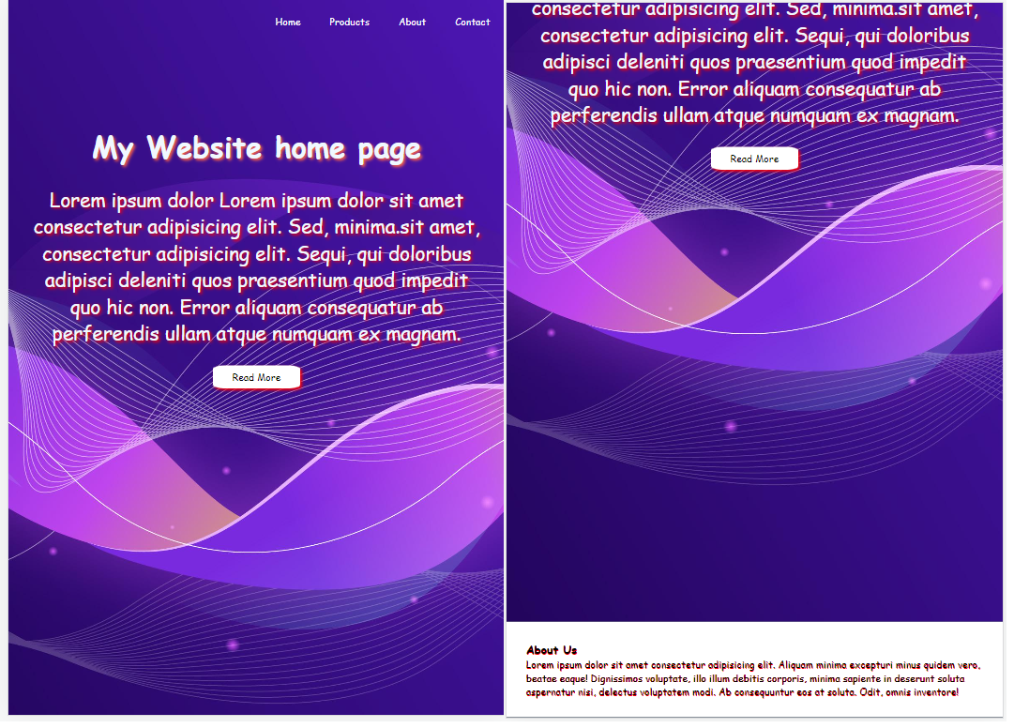\

Create following responsive website layout using flexboxes and write your appropriate media queries.

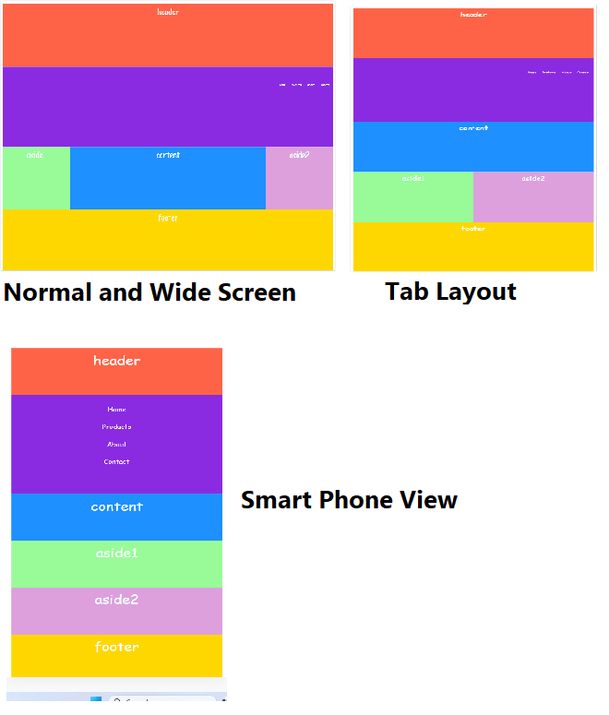

Creat following responsive web layout. Refer cssAssignment1Bootstrap.html from implementation.

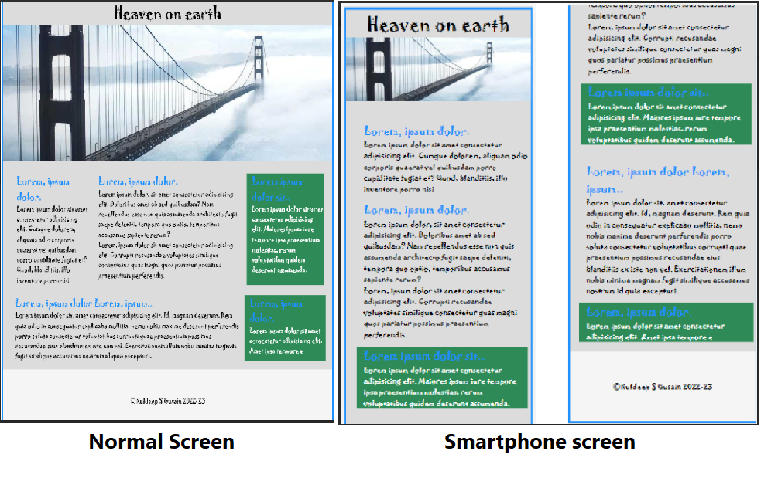

Create a responsive image grid that will accomadate image of different sizes

